**LIVE CHAT OPERATOR**

**A PROJECT REPORT**

**for**

**Mini Project-I (K24MCA18P)**

**Session (2024-25)**

**Submitted by**

**Sandali Srivastava**

**202410116100179**

**Sakshi Tripathi**

**202410116100176**

**Submitted in partial fulfilment of the**

**Requirements for the Degree of**

**MASTER OF COMPUTER APPLICATION**

**Under the Supervision of**

**Ms. Divya Singhal**

**Assistant Professor**



**Submitted to**

**Department Of Computer Applications**

**KIET Group of Institutions, Ghaziabad**

**Uttar Pradesh-201206**

**(december- 2024)**

**CERTIFICATE**

Certified that **Sandali Srivastava 202410116100179, Sakshi Tripathi 202410116100176** has/ have carried out the project work having “**LIVE CHAT OPERATOR**” (**Mini Project-I, K24MCA18P**) for **Master of Computer Application** from Dr. A.P.J. Abdul Kalam Technical University (AKTU**)** (formerly UPTU), Lucknow under my supervision. The project report embodies original work, and studies are carried out by the student himself/herself and the contents of the project report do not form the basis for the award of any other degree to the candidate or to anybody else from this or any other University/Institution.

**Ms. Divya Singhal Dr. Arun Kr. Tripathi**

**Assistant Professor Dean**

**Department of Computer Applications Department of Computer Applications**

**KIET Group of Institutions, Ghaziabad KIET Group of Institutions, Ghaziabad**

**ABSTRACT**

The role of a live chat operator is a pivotal aspect of modern customer service and engagement

strategies. These professionals serve as the first point of contact for customers seeking support,

leveraging their communication skills to provide timely and efficient responses. Operating through a live chat interface, they address a variety of inquiries, from troubleshooting technical issues to providing detailed product or service information.

Live chat operators are required to possess excellent typing speed, multitasking ability, and a customer-centric mindset. They often work in high-pressure environments where responsiveness and accuracy are critical. Beyond resolving problems, their role includes identifying sales opportunities, enhancing user satisfaction, and ensuring brand loyalty.

In an increasingly digital-first world, live chat operators embody the intersection of technology and human interaction, using empathy, knowledge, and problem-solving skills to foster meaningful customer relationships. Their contribution significantly impacts customer retention, brand reputation, and overall business success.

Keywords: Real Time Communication, Online Support, Problem Solving, Live Chat Interface.

**ACKNOWLEDGEMENTS**

Success in life is never attained single-handedly. My deepest gratitude goes to my project supervisor, **Ms. Divya Singhal** for her guidance, help, and encouragement throughout my project work. Their enlightening ideas, comments, and suggestions.

Words are not enough to express my gratitude to Dr. Arun Kumar Tripathi, Professor and Dean, Department of Computer Applications, for his insightful comments and administrative help on various occasions.

Fortunately, I have many understanding friends, who have helped me a lot on many critical conditions.

Finally, my sincere thanks go to my family members and all those who have directly and indirectly provided me with moral support and other kind of help. Without their support, completion of this work would not have been possible in time. They keep my life filled with enjoyment and happiness.

**Sandali Srivastava**

**(202410116100179)**

**Sakshi Tripathi**

**(202410116100176)**

**Table of Contents**

Certificate………………………………………………………………………ii

Abstract…………………………………………………………………………iii

Acknowledgement………………………………………………………………iv

Table Of Content………………………………………………………………..v

1. **Introduction………………………………………………………………1-5**  
   1.1 Project Description ......................................................……………… 1  
   1.2 Project Scope .......................................................................................1- 2  
   1.3 Hardware / Software Used in Project ...................................................2- 3  
   1.4 Functional Requirements ......................................................................3-4  
   1.5 Non-Functional Requirements ..............................................................4-5
2. **Feasibility Study………………………………………………………….6-12**  
   2.1 Technical Feasibility ..............................................................................6  
   2.2 Operational Feasibility ...........................................................................7-10  
   2.3 Behavioral Feasibility ............................................................................8-12
3. **Project Objective** .......................................................................................**13-14**
4. **Hardware and Software Requirements** ..................................................**15-17**
5. **Project Flow**...............................................................................................**18-22**
6. **Project Outcome…………………………………………………………23-25**

**References** ......................................………………………………………**26**

**Chapter 1**

**Introduction**

A **live chat operator** is a customer service professional who assists users in real-time through a chat platform. They handle inquiries, resolve issues, and provide guidance about products or services, ensuring a smooth and positive customer experience. Their role requires effective communication, problem-solving skills, and knowledge of the company’s offerings.

**1.1 Project Description**

The project involves providing real-time customer support via a live chat platform to ensure seamless customer experiences. The live chat operator will engage with customers to address inquiries, resolve issues, and provide detailed information about products, services, or policies. The focus is on delivering fast, accurate, and professional responses to improve customer satisfaction and retention.

They play a critical role in ensuring customer satisfaction by offering prompt, accurate, and personalized assistance. Live chat operators are a vital part of customer service teams, ensuring a seamless and satisfying user experience while helping businesses maintain strong customer relationships.

**1.2 Project Scope**

The **scope of a live chat operator** in handling college-related inquiries is vast, as they serve as the bridge between prospective/current students and the college administration. Their role enhances communication, streamlines processes, and ensures an excellent user experience for students and parents. Below is an outline of the specific scope in a college context:

1. **Course and Program Information**

* Offer detailed explanations of courses, degree programs, specializations, and career prospects.
* Help students choose programs based on their interests, goals, and qualifications.

**2. Admissions and Enrollment Support**

* Answer queries about admission procedures, eligibility criteria, and application deadlines.
* Guide students through the online application process.
* Provide information about required documents, entrance exams, and fee structures.

**3. Campus and Facilities Queries**

* Share information about campus life, hostels, sports, and extracurricular activities.
* Guide students regarding campus facilities like libraries, labs, and counseling services.

**4. Event and Examination Details**

* Share schedules for entrance exams, counseling sessions, or orientation programs.
* Provide reminders and updates for important college events or deadlines.

**5. 24/7 Accessibility for Diverse Time Zones**

* Offer round-the-clock support to cater to international students or parents with differing schedules.

**1.3 Hardware / Software Used in Project**

The hardware for a **live chat operator** is relatively straightforward and depends on the scale of the operation and the tools being used. Below is a list of essential hardware requirements:

**Hardware:**

**1**. **Computer or Laptop**

* Specifications:
  + Processor: Intel i5/i7 or AMD equivalent (for multitasking and smooth operation).
  + RAM: Minimum 8GB (16GB or higher for heavy multitasking).
  + Storage: SSD (256GB or more) for faster performance.
  + Operating System: Windows 10/11, macOS, or Linux (based on software compatibility).
* A laptop is ideal for portability, while a desktop might suit stationary setups**.**

**2. Reliable Internet Connection**

* **Speed:** Minimum 10 Mbps download/upload; higher speeds (50 Mbps+) are recommended for smooth operations.
* Use a wired Ethernet connection for stability, especially in high-traffic environments.
* **Backup:** A mobile hotspot or secondary ISP as a failover.

This setup ensures the live chat operator can work efficiently, handle multiple tasks, and maintain a professional level of service.

**Software:**

**software tools for live chat operators** that streamline customer communication and enhance support quality:

**1. Chatbot and Automation Tools**

For automating repetitive queries and assisting operators:

* **Many Chat**: Excellent for integrating automated responses on platforms like Facebook Messenger.
* **Drift**: Live chat software focused on lead generation and customer engagement.

**2. Security Tools**

To ensure secure communication and data protection:

* **LastPass**: Secure password management for operators.
* **VPN Software** : Protects sensitive chat data during operations.

The best choice of software depends on the organization’s needs, budget, and scale of operations. Many live chat tools offer **free trials**, so you can test which works best for your setup.

**1.4Functional Requirements**

The **functional requirements** for a **live chat operator** involve outlining the essential capabilities and features that both the operator and the live chat platform should possess to provide efficient customer support. Here’s a breakdown of key functional requirements:

**1. Chat Management**

* **Initiate/Respond to Chats**: The operator should be able to quickly start or respond to incoming chats.
* **Multiple Chat Handling**: Operators should manage multiple conversations at once without compromising on response quality.
* **Transfer Chats**: Ability to transfer chats to other team members or departments based on the nature of the inquiry (e.g., technical support, billing).

**2. Accessibility**

* **Multi-Language Support**: The platform should support multiple languages to assist customers from different regions.
* **Accessibility Features**: Ensure the chat platform is accessible to operators with disabilities, offering support for screen readers, high-contrast modes, and other accessibility features.

**3. Customer Information Access**

* **Customer Profile Integration**: Operators should have access to customer data such as account details, past orders, or contact information (if available) to provide personalized support.
* **Real-Time Data Access**: The system should allow operators to quickly pull up relevant customer data (e.g., product details, order status) while chatting.

The core functional requirements for a **Live chat operator** system focus on smooth, manual interactions, effective management of customer queries, and clear communication between operators and customers.

* 1. **Non-Functional Requirements**

**Non-functional requirements** for a **live chat operator** system focus on the system's overall performance, usability, reliability, security, and scalability. These requirements define how the system should behave rather than what specific features it must have. Here’s a detailed list of non-functional requirements:

**1.** **Response Time**:

* The system should ensure that operator responses to customer inquiries occur within **3-5 seconds**.
* Chat messages should be delivered in real-time, with minimal lag.
* The system should be able to handle an increasing number of concurrent chats without degradation in performance. It should scale to support **multiple operators** and high chat volumes, particularly during peak hours or marketing campaigns.

**2.Accessibility**:

* The chat interface must be **accessible** to all users, including those with disabilities. Features should include support for screen readers, keyboard shortcuts, and high-contrast modes.

**3.24/7 Accessibility**:

* The live chat platform should be available **24/7** to handle customer inquiries across different time zones.

**4.Redundancy**:

* The system should have built-in redundancy (e.g., multiple data centers) to ensure high availability, even in the event of a failure in one part of the infrastructure.

**5.Mobile Compatibility**:

* The system should be **mobile-responsive** or have a dedicated mobile app to allow operators to manage chats on smartphones or tablets.

These **non-functional requirements** ensure that the live chat platform is reliable, secure, scalable, and user-friendly, providing a seamless experience for both operators and customers. They focus on the system's behavior under various conditions, ensuring it meets performance, security, and operational goals efficiently.

**CHAPTER 2**

**Feasibility Study**

**2.1 Technical Feasibility**

A feasibility study for a live chat operator assessing the practicality, cost, and effectiveness of using human agents to handle customer interactions via live chat, rather than relying on AI-driven chatbots. Here's a breakdown of the key factors to consider:

Customer Support Quality: The primary goal is to offer personalized support where human empathy, problem-solving, and nuanced understanding are needed.

Immediate Response: Provide quick solutions to customers, as live chat offers an instant channel for communication.

Labor Costs: Human agents are paid hourly or salaried wages, which could lead to higher ongoing costs compared to AI systems that can operate 24/7 with minimal incremental costs.

Training and Onboarding: Human agents need training on products, services, communication techniques, and handling various customer scenarios. This could incur upfront costs.

Operational Costs: Expenses related to recruitment, HR processes, benefits, and office space (if not remote) must also be considered.

Shift Management: Unlike AI, which can work around the clock, human operators will require shift schedules. This adds complexity in ensuring coverage during peak hours and

Holidays.

The technical feasibility of a live chat operator system refers to the assessment of whether it is technically possible to implement and operate a live chat service that relies entirely on human operators, without the use of artificial intelligence or automated systems. This involves evaluating the technical infrastructure, system requirements, operational processes, and resources needed to ensure that human operators can effectively and efficiently handle customer inquiries in real time.It offers a personalized experience, it also presents challenges like scalability, workload management, and response time. Nevertheless, with the right infrastructure, workforce, and training, such a system can provide high-quality, efficient customer support. The focus should be on maintaining smooth operations, ensuring operator well-being, and continuously improving the service based on feedback.

**2.2 Operational Feasibility**

Operational feasibility of a live chat operator system refers to the practical aspects of implementing and running a human-driven live chat service, focusing on the operational resources, processes, and management needed to ensure the system can function effectively and efficiently. It evaluates whether the organization can support a live chat service without AI, considering factors such as workforce management, training, response times, scalability, and customer satisfaction.

Key aspects of operational feasibility for a live chat operator system include:

**1. Workforce Requirements**

Staffing Needs: Determining the number of operators required to handle peak and off-peak chat volumes.

Recruiting and training operators with the necessary skill set (e.g., communication skills, product knowledge).

Shift Management: Organizing shifts and ensuring adequate coverage during all hours of operation (24/7 or business hours).

Managing operator workload to prevent fatigue and burnout.

Team Coordination: Managing multiple chat sessions simultaneously by operators, which requires coordination and teamwork.

Ensuring operators can seamlessly escalate complex issues to higher-tier support when needed.

**2. Training and Development**

Training Programs: Providing in-depth training for operators on product knowledge, troubleshooting, and handling difficult customer situations.

Teaching operators the company's customer service policies, communication standards, and brand tone.

Ongoing Training: Ensuring continuous learning for operators to stay updated on new products, services, or changes in company policies.

Regular performance evaluations and feedback to improve operator efficiency and customer interaction quality.

**3. Chat Management**

Chat Load Distribution: Ensuring that chats are appropriately distributed among operators so that no one operator is overloaded, especially during high-traffic periods.

Implementing a queue system to manage incoming chats and ensure that customers do not have long wait times.

Handling Concurrent Chats: Operators must be able to manage multiple chats at once without compromising the quality of service.

Proper UI/UX design for operators to navigate multiple chats effectively.

**4. Customer Interaction and Satisfaction**

Response Time: Ensuring that response times remain fast and consistent, as delays can lead to customer dissatisfaction.

Managing expectations by providing estimated wait times when there are delays.

Quality Assurance: Monitoring chat quality through regular audits or supervisor oversight to ensure operators maintain professionalism and provide accurate information.

Ensuring that customer interactions are friendly, empathetic, and aligned with company values.

Escalation Protocol: Developing clear procedures for escalating chats to more experienced agents or support teams when complex issues arise.

Tracking the resolution of escalated issues to ensure customers are satisfied with the outcome.

**5. System and Technology Maintenance**

Live Chat Software Support: Ensuring that the live chat platform is reliable and always operational, with minimal downtime.

Managing any technical issues that may arise, such as system errors, security breaches, or software updates.

Integration with Other Tools: Integrating the live chat platform with other operational systems, like CRM, ticketing, or knowledge bases, to streamline the workflow for operators.

Performance Monitoring: Continuously monitoring the system to ensure that response times, system uptime, and chat volumes are within acceptable thresholds.

**6. Scalability and Flexibility**

Handling Increased Volume: The ability to scale up operations during peak times (e.g., holiday sales, product launches) by hiring temporary staff or adjusting shifts.

Managing customer chat volume spikes and ensuring that the system remains responsive and efficient.

Adapting to Customer Needs: Flexibility to adapt to changing customer expectations, such as providing new services or adapting the chat format.

The ability to handle different types of inquiries, such as sales, technical support, or general customer service.

**7. Cost and Resource Allocation**

Operational Costs: Assessing the ongoing costs of employing live chat operators, including salaries, benefits, and training.

Managing the cost of maintaining software and infrastructure, including licensing fees, server hosting, and support.

Budget Management:

Ensuring that resources are allocated efficiently to avoid overstaffing or understaffing.

Balancing operational costs with customer satisfaction and service quality.

**8. Customer Feedback and Continuous Improvement**

Collecting Feedback: Gathering customer feedback after each chat session to evaluate satisfaction and identify areas for improvement.

Implementing regular surveys or follow-ups to measure customer experience and pinpoint pain points.

Performance Review: Regularly reviewing operator performance through metrics like customer satisfaction, response time, and issue resolution rates.

Using feedback from both customers and operators to improve the service and identify opportunities for process optimization.

**9. Compliance and Legal Considerations**

Data Privacy: Ensuring that all customer information shared during chat sessions is handled in compliance with data privacy regulations (e.g., GDPR, CCPA).

Properly storing chat logs, adhering to legal retention policies, and ensuring secure access to sensitive data.

Security: Implementing security measures to prevent unauthorized access to the system, including encryption of chat conversations and authentication of operators.

**2.3 Behavioral Feasibility**

Behavioral feasibility of a live chat operator system refers to the assessment of whether the human aspects of the system—such as the behavior, attitudes, capabilities, and interactions of the operators and customers—will support the success and effectiveness of the system. It focuses on how well human operators can perform under various circumstances and how customer interactions are handled, ensuring both sides (operators and customers) are satisfied with the experience.

Key factors involved in the behavioral feasibility of a live chat operator system without AI include:

**1. Operator Behavior and Capabilities**

Communication Skills: Operators need strong verbal and written communication skills to effectively convey information, resolve issues, and maintain a positive tone throughout interactions.

Empathy and Emotional Intelligence: Human operators must be capable of empathizing with customers, understanding their emotional state, and responding appropriately to defuse tension or frustration.

Multitasking and Stress Management: Operators will need to manage multiple concurrent chats, which requires strong multitasking abilities, focus, and stress management. If operators struggle with this, it could impact service quality.

Consistency and Professionalism: Ensuring that operators consistently provide accurate, helpful, and professional responses, maintaining the company’s standards across all interactions. Behavioral inconsistencies could lead to customer dissatisfaction.

**2. Customer Behavior and Expectations**

Response Expectations: Customers expect fast and effective responses, which may create pressure on human operators. Customers used to AI-powered chatbots may have a higher expectation of instant replies, making it more challenging for operators to meet these demands without compromising quality.

Tolerance for Wait Time: Human-driven live chats typically have longer response times compared to AI systems. Understanding how customers will react to these delays—whether they will tolerate them or become frustrated—is key for the system’s behavioral feasibility.

**3. Team Dynamics and Operator Interaction**

Collaboration Among Operators: Since operators may need to escalate chats to more experienced colleagues or work in teams for complex issues, collaboration is important. Good team dynamics ensure smooth transitions, support for each other, and a unified approach to customer issues.

Support from Supervisors: Effective leadership and supervisor support are essential to guide operators and handle difficult or escalated cases. Supervisors should be able to monitor operator behavior and provide guidance when needed.

Performance Monitoring and Feedback: Continuous monitoring and feedback ensure that operators are maintaining quality, efficiency, and professionalism. The feedback loop can help operators adjust behavior, improve performance, and stay motivated.

Operator Motivation and Engagement: Live chat operators should be motivated to perform well, especially when working in high-pressure or high-volume environments. Motivation can be influenced by factors such as job satisfaction, clear performance metrics, recognition, and opportunities for growth.

**4. Behavioral Expectations from Management**

Clear Guidelines and Standards: Management must set clear behavioral standards and guidelines for operators, covering areas like customer tone, professionalism, resolution timelines, and escalation procedures. This ensures uniformity in customer interactions.

Workforce Planning and Flexibility: Understanding and planning for human factors such as peak demand times, operator fatigue, and shift work is essential. Flexible work schedules and proper planning can prevent burnout and maintain consistent operator performance.

**5. Behavioral Impact on Customer Satisfaction**

Trust and Confidence: Customers often feel more trust and confidence in human interactions compared to automated responses, especially when they receive personalized attention. Operator behavior in fostering trust can lead to higher customer satisfaction.

Resolution Satisfaction: The ability of operators to effectively solve customer problems or answer queries in a clear, concise, and friendly manner directly impacts customer satisfaction. Customers appreciate an operator who listens and resolves issues efficiently.

Customer Loyalty: Positive, empathetic, and professional interactions from operators can lead to higher customer retention and loyalty. Customers are likely to return to a service if they feel valued and understood during interactions.

## Chapter 3

## Project Objective

A live chat operator without AI plays a crucial role in providing customer service and support through real-time chat communication. They are responsible for assisting customers, answering inquiries, and resolving issues promptly and effectively. The objective of a live chat operator without AI involves several key goals and responsibilities, which can be detailed as follows:

**1. Providing Real-Time Customer Support**

The primary objective of a live chat operator is to offer immediate assistance to customers. Unlike emails or phone calls, live chat allows customers to get answers and solutions in real-time. This instant communication enhances customer satisfaction and helps businesses maintain positive relationships with their clients.

**2. Personalized Communication**

Live chat operators are expected to provide personalized support. They engage with customers using a conversational tone, addressing their individual needs and tailoring solutions based on the customer's unique situation. By doing so, operators ensure customers feel valued and understood.

**3. Problem Resolution**

Live chat operators must quickly identify and address issues raised by customers. This could involve troubleshooting technical problems, clarifying product details, resolving billing issues, or offering product recommendations. They aim to resolve the customer’s issue or provide a clear solution in the shortest time possible, which contributes to increased customer loyalty and satisfaction.

**4. Handling Multiple Chats Simultaneously**

A key skill of live chat operators is the ability to handle multiple conversations at the same time, ensuring each customer receives timely responses. This is an essential part of the job in busy environments where high volumes of inquiries are common.

**5. Reducing Customer Wait Time**

One of the significant advantages of live chat is the reduced wait time compared to other communication channels like phone support or email. Operators aim to manage and minimize wait times, making sure customers are not left waiting for long periods.

**6. Maintaining Customer Satisfaction**

Live chat operators are focused on enhancing the customer experience by providing fast, accurate, and friendly support. Customer satisfaction is often measured by how quickly issues are resolved and how well the operator communicates. Operators should follow guidelines for communication etiquette to maintain professionalism.

**Key Points:**

**Real-Time Assistance:** Live chat operators provide instant support, helping customers solve problems immediately. This is crucial in situations where fast resolutions are needed, such as technical issues, billing inquiries, or product recommendations.

**Human Interaction:** Unlike AI-driven systems, live chat operators engage in personalized communication, adapting their responses to the unique needs and emotions of the customer. They offer empathy, understanding, and the ability to resolve complex issues that AI may struggle with.

**Problem Resolution:** Operators aim to understand the customer’s issue and provide a clear, accurate solution. They may troubleshoot technical problems, answer product-related questions, or assist with account or order-related concerns.

Live chat operators need to be well-versed in the company's products, services, and internal systems to provide accurate information quickly. They also contribute to maintaining and updating knowledge bases by providing feedback from customer interactions.

**Feedback Collection and Continuous Improvement:** Live chat operators are valuable sources of feedback. By engaging with customers, operators can gather insights into recurring

problems, popular features, or areas of improvement. This feedback can be used by the business to improve products or services.

**Chapter 4**

**Hardware and Software Requirements**

To operate effectively as a live chat operator, you need specific hardware and software to ensure smooth communication, fast response times, and reliable service. Below is a detailed breakdown:

**Hardware Requirements**

**1. Computer or Laptop**

* Processor: Minimum Intel i5 or equivalent; Intel i7 or equivalent recommended for multitasking.
* RAM: Minimum 8GB; 16GB recommended for seamless multitasking.
* Storage: 256GB SSD or higher for faster boot times and quick data access.
* Operating System: Windows 10/11, macOS, or a modern Linux distribution.
* Display: Minimum 13-inch screen; Full HD (1920x1080) resolution or higher for clear visibility of multiple chat windows.

**2. Reliable Internet Connection**

* Speed: At least 10 Mbps download/upload; 50 Mbps or higher recommended for a stable connection during peak hours.
* Backup: A secondary connection (e.g., mobile hotspot) in case of primary internet failure.

**3. Headset or Microphone (Optional but Useful)**

* High-quality noise-canceling headset if voice chat or video conferencing is required.

**4. Peripherals**

* Keyboard and Mouse: Ergonomic setup for comfort during extended use.
* Webcam: For video calls or identity verification, if needed.

**5. Power Backup**

* UPS or power bank for laptops to avoid downtime during power outages.

**Software Requirements**

**1. Operating System**

* Windows, macOS, or Linux with regular updates and security patches.

**2. Browser**

* A modern web browser like Chrome, Firefox, Edge, or Safari. Ensure it's updated to the latest version for compatibility with live chat platforms.

**3. Live Chat Software**

* Examples: Zendesk Chat, Live Chat, Intercom, Freshchat, or Tawk.to. These are typically provided or recommended by your employer or client.
* Ensure the software supports integrations like CRM systems, ticketing tools, and analytics.

**4. Communication Tools**

* Email Client: Outlook, Gmail, or other email tools for escalations and follow-ups.
* Collaboration Tools: Slack, Microsoft Teams, or similar for internal communication.

**5. Security Tools**

* Antivirus/Antimalware: Protect against malicious threats (e.g., Norton, Bitdefender, or Windows Defender).
* VPN: Ensure secure and encrypted internet access, especially if handling sensitive customer data.

**6. Productivity Tools**

* Typing Software: Tools like Grammarly for grammar checks and fast, accurate typing.
* Clipboard Manager: To save time when copying and pasting repetitive responses.
* Automation Tools: If allowed, tools like macros or text expanders (e.g., TextExpander) for efficiency.

**7. Monitoring/Analytics Tools**

* For tracking performance metrics, customer satisfaction, and chat volume.

Optional Enhancements

* Dual Monitors: Improves productivity by allowing multiple applications to be visible simultaneously.
* Mobile Device: A smartphone or tablet for accessing live chat software or communication tools on the go.

**Chapter 5**

**Project Flow**

The **project flow for a live chat operator** refers to the step-by-step process that ensures efficient communication between a customer and a live chat operator. Below is a typical flow:

**5.1 Initiation of Chat**

* **Customer Entry Point:**
  + Customer initiates a chat through a chat widget on the website, app, or other platforms.
  + Pre-chat form may collect basic information (e.g., name, email, and query type).
* **Automated Greeting:**
  + System sends an auto-response (e.g., "Hello! How can we assist you today?").

Here’s a detailed project flow for a **Live Chat Operator** system, outlining the steps and components needed for development and operation:

**5.2 Project Planning**

**1.1 Define Objectives**

* Improve customer support response time.
* Enhance customer satisfaction and retention.

**1.2 Identify Stakeholders**

* Customers
* Live Chat Operators
* Supervisors/Team Leads
* IT/Development Team

**5.3 System Design**

**Architecture**

* Frontend (chat widget): Embedded on the website or mobile app.
* Admin Dashboard: Monitor operator performance, view metrics.

**Features**

**Customer-side Features:**

* Easy-to-use chat interface.
* Pre-chat form (name, email, query category).
* Automated welcome message.
* Option to escalate to a human operator.

**5.4 Development Phases**

**Prototype Development**

* Develop a basic chat widget and backend server for testing.
* Mock workflows for operators and customers.

**Frontend Development**

* Build and test the chat widget.
* Optimize for different devices and browsers.

**5.5 Daily Monitoring**

* Ensure operators are handling chats effectively.
* Monitor for any system downtime or bugs.
* Operator performance (e.g., chats handled/hour).

**5.6. Long-term Maintenance**

* Regularly update the system to fix bugs and add features.
* Scale the infrastructure as chat volume increases.
* Offer refresher training to operators.

Let me know if you'd like me to focus on a specific aspect of this project or expand on any

The **project flow for a live chat operator** refers to the step-by-step process that ensures efficient communication between a customer and a live chat operator. Below is a typical flow:

**USE CASE DIAGRAM :**

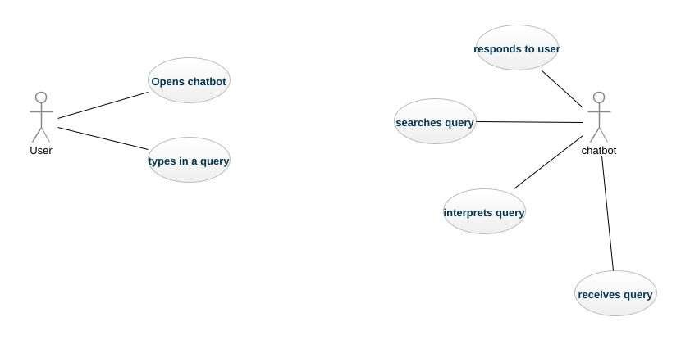

Figure 5.1

In figure 5.1 A use case diagram in the context of a live chat operator system is a visual representation of the interactions between users (actors) and the system. It captures the functionalities or "use cases" that the system provides and the relationships between the live chat operator, customers, and other system components.

**0 Level DFD**

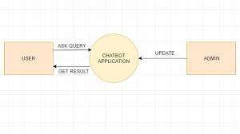

Figure 5.2

In figure 5.2 A 0-level Data Flow Diagram (DFD), also known as a context diagram, represents the entire live chat operator system as a single process and shows how it interacts with external entities. It provides a high-level overview of the system, focusing on the flow of data between the system and its external actors without delving into internal details.

**1 Level DFD**

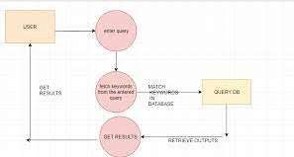

Figure 5.3

In figure 5.3 A 1-level Data Flow Diagram (DFD) for a Live Chat Operator System breaks down the single process from the 0-level DFD into smaller subprocesses. It provides more detail about how data flows within the system and how each subprocess interacts with external entities and other subprocesses.

**E-R DIAGRAM :**

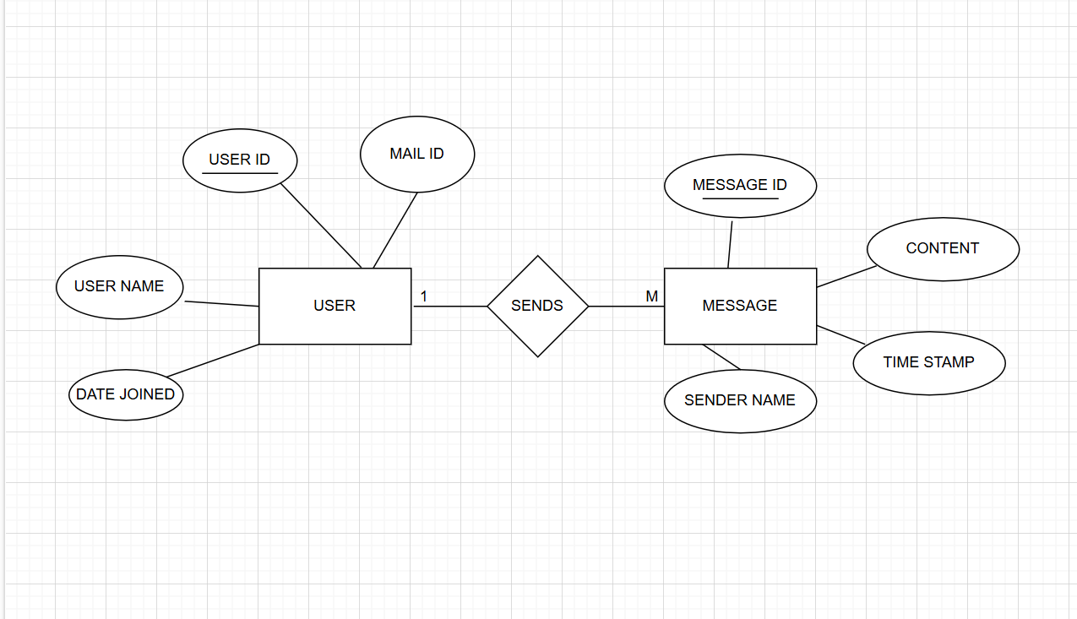

Figure 5.4

In figure 5.4 An **Entity-Relationship (ER) Diagram** for a **Live Chat Operator System** is a visual representation of the system's data model. It defines the entities, their attributes, and the relationships between them. This diagram helps in designing the database structure to support the functionalities of the live chat system.

**Chapter 6**

**Project Outcome**

**Live Chat Operator System** is implemented for **college purposes**, the outcomes will be tailored to enhance administrative efficiency, student support, and campus communication.

**student-related queries** in a college setting, the **outcomes** will center on providing effective support for students’ academic, administrative, and personal needs.

**6.1 Query Resolution Outcomes for Students:**

* **Instant Response to Admissions Queries**:
  + Students can get immediate answers about admission requirements, deadlines, eligibility, and document submission.
* **Program and Course Information**:
  + Students can inquire about available programs, course details, prerequisites, syllabus, and academic policies.

**Student Support Services**:

* Information regarding counseling, mental health services, career support, internships, and extracurricular activities can be made accessible.

**Campus Life Queries**:

* Students can inquire about campus events, clubs, housing, dining facilities, and transportation options.

**6.2 24/7 Availability and Accessibility:**

**Access Across Devices**:

* Students can use the system on the college website, mobile app, or social media platforms, ensuring support is always available.

**6.3 Feedback and Satisfaction:**

* **Real-Time Feedback Collection**:
  + After a chat session, students can provide feedback on the assistance received, helping improve the service.
* **Improved Student Experience**:
  + Reduced wait times and fast, accurate answers lead to a higher level of student satisfaction with college services.
* **Self-Service Support**:
  + By accessing a well-maintained knowledge base, students can resolve issues on their own, improving efficiency for both students and the support team.

By focusing on **student-related queries**, a **Live Chat Operator System** can significantly enhance students’ academic experience and streamline their interactions with the college’s administrative systems.

**6.4 INTERFACE :**

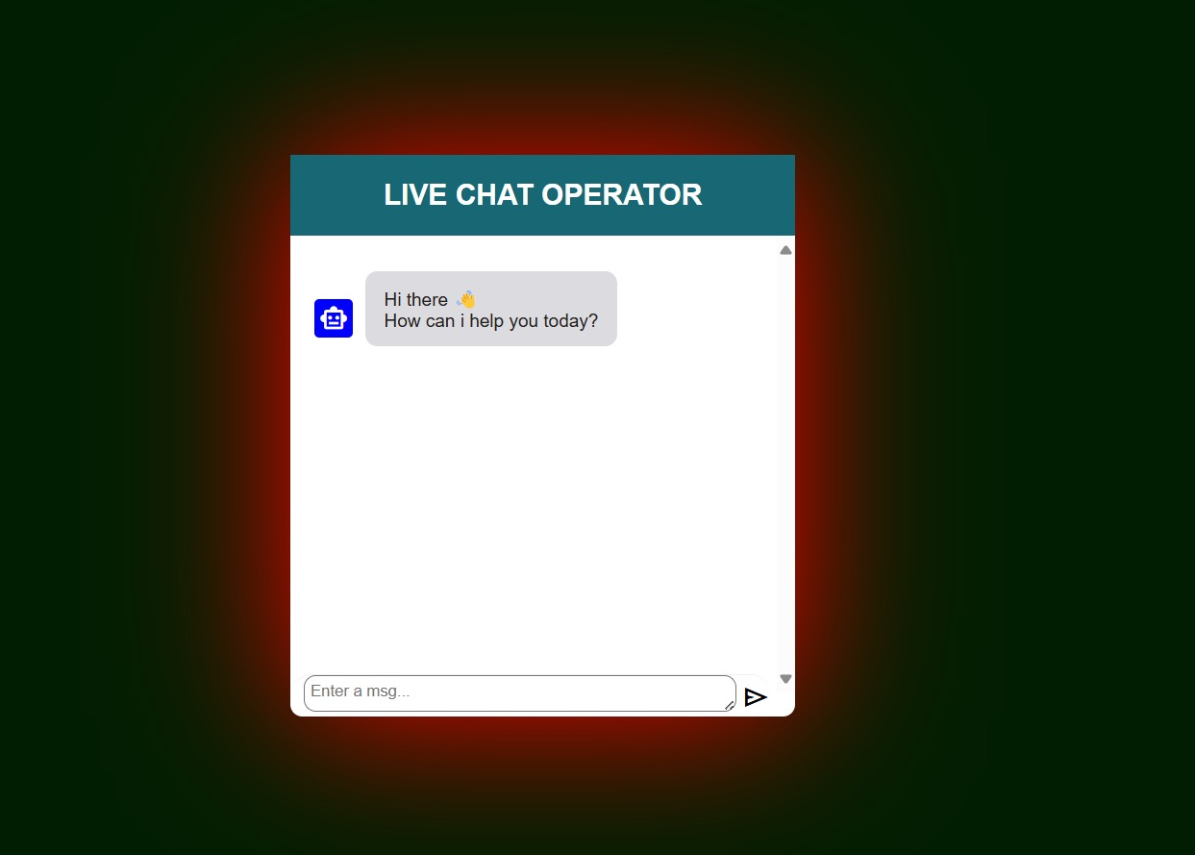

Figure 6.4.1

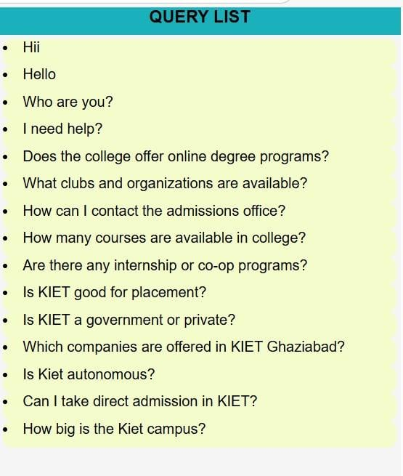

Figure 6.4.2

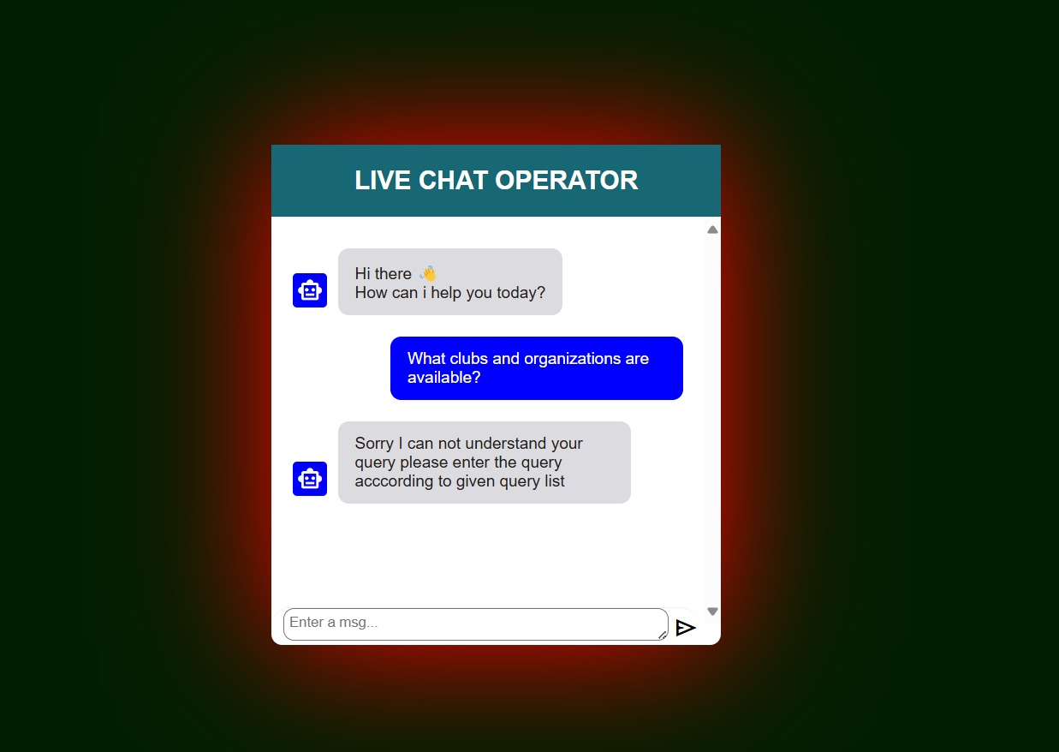

Figure 6.4.3

**REFERENCES**

1. Zendesk. (2024). *Live Chat for Customer Service*. Retrieved from https://www.zendesk.com/live-chat/
2. Provides an overview of live chat systems, features, and how they enhance customer support.
3. Live Chat (2023). *Best Practices for Live Chat Support*. Retrieved from https://www.livechat.com/blog/best-practices/
4. <https://in.search.yahoo.com/search?fr=mcafee&type=E210IN826G0&p=coding+nepal>
5. <https://www.w3schools.com/python/exercise.asp?x=xrcise_variables_output2>
6. <https://chatgpt.com/c/676059f1-bef8-8001-b92c-d19dd511cb62>
7. <https://in.search.yahoo.com/search?fr=mcafee&type=E210IN826G0&p=google+.com>